The Medium
A live working paper • 10 September 2026
Relational completion across language, script, music and electronic circuits

Abstract
A medium determines how partial contributions can become one reusable object. This paper specifies that question through local restrictions, lawful completions, retained state and validity under later composition. Language, script and music provide the principal interpretive domains; electronic circuits supply exact engineering realizations. A switched passive network gives a concrete failure of present-output reduction: a hidden state produces a 25.296 mV echo only after contexts are composed. Encoding and rhythm fixtures provide further compositional checks. The empirical scope remains explicit: language and music-corpus contributions are source-table audits, while the new physical calculations are ideal-model results.

1. A state includes what can matter later
A record is useful because it can constrain another event. A phrase becomes input to a sentence; a written cluster becomes input to a reader; a musical return changes the next expectation; a circuit output drives another stage. A description of the completed object is sufficient only when the discarded details cannot alter any admitted later use.
$$πz=π\tilde{z} ⇒ π^{′}U\left(z\right)=π^{′}U\left(\tilde{z}\right).$$
Here z is a complete carrier state, including relevant memory and constitution; π is the proposed reduced description; U is an admitted operation. This implication is the exact condition for a well-defined effective update. The operation may change the state description, giving output map π′. For stochastic states, it applies to the full pushed-forward outcome law.
An event may have many internal implementations and still be one effective object. What matters is their equivalence in the declared future contexts. Equality of current outputs is a weaker test. Approximate equality also requires explicit error accounting because pairwise closeness need not form an equivalence relation.
The present theory is a modelling architecture, not a claim that all carriers share one physical substance. Its content lies in the chosen state, constitutive laws, boundary operations and discriminating measurements. Established circuit and encoding mathematics provide exact instances; the natural-medium interpretations remain hypotheses. [1,10,13]

2. The common mathematical object
$$T_{Γ}=\left(X_{Γ},A_{Γ},g_{Γ},B_{Γ},I_{Γ}\right).$$
The entries specify admissible support, directed transport, observation-dependent distinguishability, a lawful joined relation and a retained completion law. Constitution Γ also contains kinetic parameters and allowed interventions. The notation separates the conditions for a process from the state currently realized within them.
The elemental coordinates Ākāśa, Vāyu, Tejas, Jala and Pṛthvī name those five proposed roles. Samāna is the operation that constructs a common relation; Agni records a distinction through the chosen observation geometry; Udāna exposes a stable product to another scale; Apāna clears future-inert detail. Admission and identity-preserving reach are Prāṇa and Vyāna. Ojas denotes a declared margin to operational failure. These are definitions within the model, not deductions establishing a unique elemental ontology.
$$F_{Γ}\left(R\right)=\{Ω:{res}_{i}Ω=R_{i} \text{for all }i\}.$$
The completion fibre is the set of lawful wholes satisfying the local restrictions. An empty fibre is incompatibility; multiple distinguishable wholes are ambiguity. A completion score can measure distance to this set, provided its topology and attainment conditions are stated. Consistency with a model remains separate from truth about the world.
$$K_{t_{2},t_{0}}=K_{t_{2},t_{1}}∘K_{t_{1},t_{0}}.$$
This gluing law requires a sufficient boundary state. Its composition may be Boolean existence, cost minimization or integration over stochastic intermediate states. Changing parentheses for the same ordered process is a different test from changing the temporal order of the process itself.
A static completion cost can specify a susceptibility on a smooth stable branch: χ = H⁻¹ for Hessian H. The restoration generator also contains mobility, giving MH. Electrical capacitance makes the distinction concrete. A positive observation metric, a dissipated-power objective and stored energy retain different meanings and units.
These two pages provide the common formal core. The remaining sections specify application-dependent variables and the evidence available for each. The question is always which distinction the receiver or downstream process can still detect.

3. Language: role, path and closure
Language joins restrictions on participants, events, time, scope and reference. Sound, morphology, order, prosody, script and discourse can constrain different parts of that join. A receiver can record one relation while a larger expression remains unfinished. The same word sequence can therefore produce different completion states under different retained contexts.
Three order-related quantities deserve separate names. Role coding concerns whether position helps distinguish a subject from an object. Eventward organization concerns where contributions accumulate relative to a predicate. Suspension concerns the span over which a relation remains structurally open. One word-order label does not determine all three.
Language | Root position | Predicate span | Order bits | Morphology bits
English | 0.413 | 0.123 | 0.691 | 0.350
French | 0.385 | 0.080 | 0.540 | 0.323
Spanish | 0.346 | 0.088 | 0.424 | 0.266
German | 0.431 | 0.349 | 0.104 | 1.228
Russian | 0.378 | 0.117 | 0.340 | 1.046
Mandarin | 0.675 | 0.158 | 0.859 | 0.087
Hindi | 0.656 | 0.081 | 0.153 | 0.450

Table 1. Rounded estimates inherited from a seven-language PUD analysis in a supplied reference note. These values were transcribed and arithmetically audited, not re-estimated from raw corpora. Bits concern a subject/object/oblique prediction task. [2,13]
The reported German profile combines a wide predicate span with strong morphology-based role recovery. The Hindi profile combines a late root and compact predicate cluster with similarly directed subjects and objects. Mandarin combines strong role-side separation with a late root. These observations motivate distinct structural coordinates; they do not identify a measured sequence of mental operations. [2]
English is order-heavy in this task, Russian morphology-heavy, and the French and Spanish joint predictors improve substantially over their stronger isolated channel. The relevant contribution is a target-specific cue profile. A profile supplies no ranking of a language’s general expressive or cognitive capacity. [2]
Universal Dependencies encodes morphosyntactic relations. Its syntactic words, multiword-token ranges and empty nodes have different roles in CoNLL-U. Any replication must retain those distinctions. These treebank quantities do not directly observe acoustic timing, listener physiology or the instant at which meaning is resolved. [3,4]

4. Language: conjunction and retained meaning
O denotes the selected order features and M the selected morphology features. Each Λ is a reported held-out reduction in cross-entropy relative to its baseline. The increment Δ compares the joint predictor with the stronger isolated predictor.
$$Δ={\hat{Λ}}_{O,M}−max\left({\hat{Λ}}_{O},{\hat{Λ}}_{M}\right).$$
The inherited joint increments are 0.148 bits for English, 0.191 for French, 0.234 for Spanish, 0.008 for German, 0.035 for Russian, 0.046 for Mandarin and 0.081 for Hindi. Recalculation from the displayed single-channel and joint values reproduces every increment. Display rounding alone permits a conservative ±0.001-bit range. This is not sampling uncertainty. [2,13]
Predictive improvement from combined cues is evidence about a specified predictor and target. It is not automatically mutual information, causal fusion or a unique mathematical measure of synergy. The baseline, feature provenance, annotation completeness, train/test grouping and learned model must be known to support those stronger interpretations.
For a future completion analysis, the relevant experimental objects would be the restriction being changed and the relation being recovered. Removing a marker can enlarge a role fibre; delaying a predicate can prolong a structural dependency; changing prosody can affect scope. These are distinct candidate mechanisms even when their final sentence-level answer agrees.
The earlier Telugu example suggests that a surface-form channel can carry distinctions absent from sparse feature annotation. Its original statistic and permutation test were not rerun. The Classical and Vedic Sanskrit samples are also separate, incomparable cases in the supplied record. A controlled historical or cross-language estimate cannot be obtained by treating those aggregates as matched observations. [2]
Translation makes the operational criterion explicit. Two expressions can preserve answers to a declared family of questions about participants, timing, scope and reference while using different forms and processing paths. An adequate translation map must preserve those consequences to a stated tolerance; preserving word order is neither its definition nor a universal requirement.
Learning changes the receiver’s later completion law. A persistent grammatical or lexical update belongs in constitution; momentary uncertainty belongs in the live state. The theory can describe that distinction without assuming that one particular learning rule or physical carrier has already been established.
The linguistic contribution of this paper is consequently a clarified object and an honest audit of inherited coordinates. Raw-corpus re-estimation and direct processing measurements remain absent. No new p-values, confidence intervals or cross-language causal conclusions are attached to the source tables.

5. Script: a boundary that composes exactly
A writing system presents several different units: code points, graphemes, rendered forms and reader-level objects. Canonical normalization supplies an exact encoding-layer example of how a boundary can support stable composition. It also shows why individually valid parts can still need work at their interface. [5,6]
$$a⋆b=N\left(ab\right), N\left(N\left(a\right)N\left(b\right)\right)=N\left(ab\right).$$
N is NFC normalization. The code points “e” and U+0301, the combining acute accent, are individually normalized; their raw concatenation can still require normalization to the precomposed character “é”. Defining the joining operation to normalize the complete boundary makes the resulting operation associative under canonical equivalence. [5]
Tested representation | Code points | Extended graphemes
café / cafe + U+0301 | 4 / 5 | 4 / 4
ä / a + U+0308 | 1 / 2 | 1 / 1
й / и + U+0306 | 1 / 2 | 1 / 1
कि / కి | 2 / 2 | 1 / 1
休 | 1 | 1

Table 2. Nine executed string fixtures. All literal text and code-point sequences are included in the supplement. [13]
All five binary parenthesizations of the chunks “c”, “a”, “fe” and U+0301 produce the same NFC string when every join is normalized. The test certifies a small, declared boundary interface. It supplies no claim that code points or default grapheme clusters are universal perceptual units. [13]
Higher script layers require their own state. Graphic similarity, pronunciation, lexical identification, layout and motor construction can preserve different future tasks. A handwriting path may be irrelevant to ordinary reading and remain relevant to motor learning. A visual or acoustic equivalence is therefore defined relative to the actual receiver question.
The tested Unicode database is 15.1.0 with regex 2026.5.9. Nine fixtures do not establish complete conformance with Unicode 17.0 or script-specific shaping rules. The current result is exact enough to demonstrate composition while narrow enough to avoid converting encoding success into an unmeasured theory of reading. [5,6,13]

6. Music: a hidden relational difference in equal power
A periodic sound can be specified relative to a retained pulse, phrase or harmonic context. Two signals with equal energy distribution can occupy different places in that reference. The following fixture isolates that distinction without assuming a theory of pleasure, emotion or physiology.
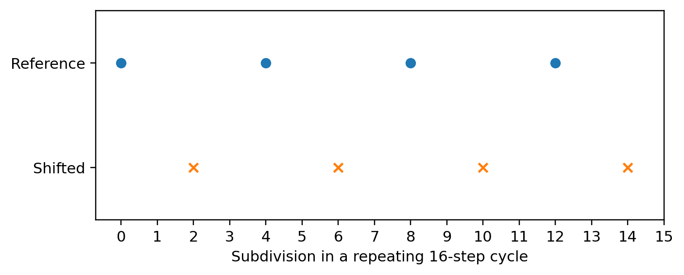
Figure 1. Two 16-step onset trains. The second is shifted by two subdivisions relative to a fixed four-step reference.
The first train has onsets at 0, 4, 8 and 12; the second at 2, 6, 10 and 14. Their Fourier magnitudes and power spectra agree because a cyclic shift changes Fourier phase without changing magnitude. Yet their phase relative to the four-step metrical reference differs by π. [13]
z=1Nonn∈onsets​e2πin/4, zA=zB=1.
Coherence magnitude is also identical. A state description containing only power and coherence strength therefore loses a distinction that a phase-sensitive downstream operation can detect. The required addition is the relation to a reference, not a larger unstructured list of sound features.
Uniform tempo rescaling preserves normalized interval ratios in the executed control, and uniform pitch transposition preserves successive pitch intervals. These are declared algebraic invariances. They do not demonstrate listener-level invariance, preservation of timbre, a genre label or equivalent expressive force. [13]
A completion model for music must retain whichever of pulse, melodic contour, timbral development, harmonic context and phrase history changes the admitted next question. Closure is scale-relative: one rhythmic or harmonic unit can finish while the larger musical relation remains open.

7. Music: the measured and the proposed
Cross-cultural rhythm-reproduction research reports common tendencies and culturally variable category weights. Research on groove has also found that intermediate syncopation in sampled drum breaks can be rated more pleasurable and more movement-inducing than the extremes. These are empirical findings from their stated tasks. They motivate constituted receiver models without selecting the present elemental interpretation. [8,9]
Groove split | Files | Measures | Note hits | Minutes
Training | 897 | 17,752 | 357,618 | 648.5
Validation | 124 | 2,269 | 44,044 | 82.2
Test | 129 | 2,193 | 43,832 | 84.3
Total | 1,150 | 22,214 | 445,494 | 815.0

Table 3. Published Groove MIDI Dataset aggregate counts. This paper checked the arithmetic of the source table; it did not analyse the raw performances. [7,13]
Counts of files, measures and note hits do not provide independent samples of musical preference. The aggregate table yields no performer-level uncertainty, timing-deviation distribution or causal genre comparison. No new learner was fitted or tested against the displayed splits.
Different musical settings propose different completion questions. A groove-based passage may require pulse-relative placement. A harmonically directed phrase may require a continuation set. Ornament-dependent melodic material may require a context-sensitive contour. Textural material may require a long timbral trajectory rather than a recurring beat. These are model specifications awaiting carrier- and receiver-specific tests.
The proposed terms therefore remain operational: integration is the formation of a relation that survives the relevant continuation; discrimination is the recording of a difference; retention is what alters later hearing or action; clearance removes detail only when later tasks cannot recover it. A descriptive resemblance between a cadence and release is not itself an identified mechanism.
The exact result is the failure of an insufficient phase-blind reduction. The empirical programme remains broader: determine whether retaining the specified relational state improves prediction of measured performance, expectation or comprehension. This paper supplies no new evidence about bodily coupling, acoustic health effects or the aesthetic superiority of any musical form.

8. Electronic circuits: exact completion and reuse
Circuit theory gives the architecture an independently specified physical realization. Component relations and charge balance determine a compatible electrical state. A terminal description can replace internal detail for one task, provided it preserves the boundary law. Passive resistor networks make that operation exact. [10]
Branch | Conductance (mS)
0–1 | 1
1–2 | 2
2–3 | 1
0–2 | 0.5
1–3 | 0.5

Set boundary voltages v₀ = 1 V and v₃ = 0 V. For this network, Kirchhoff balance gives internal voltages v₁ = 6/11 V and v₂ = 5/11 V, input current 8/11 mA and dissipated power 8/11 mW. With L = B diag(g) Bᵀ, elimination gives the following terminal matrix. [13]
$$L_{red}=L_{BB}−L_{BI}L_{II}^{−1}L_{IB}=\frac{8}{11}\left(\begin{matrix}1 & −1 \\ −1 & 1\end{matrix}\right) mS.$$
The internal block is positive definite, so the completion is unique. Both orders of internal elimination produce the same terminal relation. The terminal object is therefore autonomous for the declared DC boundary task. The quadratic objective ½vᵀLv has power units; it must not be mistaken for stored capacitor energy. [10]
The supplement repeats this verification on 1,000 positive networks with branch conductances from 0.1 to 10 mS. It checks boundary current, internal balance, power and both elimination orders. The largest elimination-order discrepancy is 5.33 × 10⁻¹⁵ mS. These are numerical implementation checks accompanying an exact algebraic identity. [13]
A capacitor adds a hidden dynamical state. Two circuits can have the same DC terminal response and different transient consequences. A state reduction that is valid for static loading can fail after switching or coupling to another stage. The next example identifies that failure directly.

9. Electronic circuits: a context-dependent echo
Take three 1 µF capacitors, a conductance unit of 1 mS and a time unit of 1 ms. In dimensionless time, dv/ds = −Mᵢv. Both allowed configurations below are passive resistor networks, and the observation is v₁.
$$M_{1}=\left(\begin{matrix}2 & −1 & 0 \\ −1 & 2 & 0 \\ 0 & 0 & 2\end{matrix}\right), M_{2}=\left(\begin{matrix}2 & 0 & 0 \\ 0 & 2 & −1 \\ 0 & −1 & 2\end{matrix}\right).$$
M₁ links nodes 1–2 through 1 kΩ, grounds those nodes through 1 kΩ each and grounds node 3 through 500 Ω. M₂ links nodes 2–3 and puts the 500 Ω ground at node 1. Switching is ideal, with continuous capacitor voltages and no charge injection.
Prepare v(0) = (0, 0, 1) V. Either fixed configuration gives zero observation for every time. Configuration 1 followed by 2 also gives zero. Configuration 2 for 1 ms followed by 1 for 1 ms gives the exact response below. [13]
$$e_{1}^{T}e^{−M_{1}}e^{−M_{2}}e_{3}=e^{−4}\sinh^{2}\left(1\right)≃0.025295689.$$
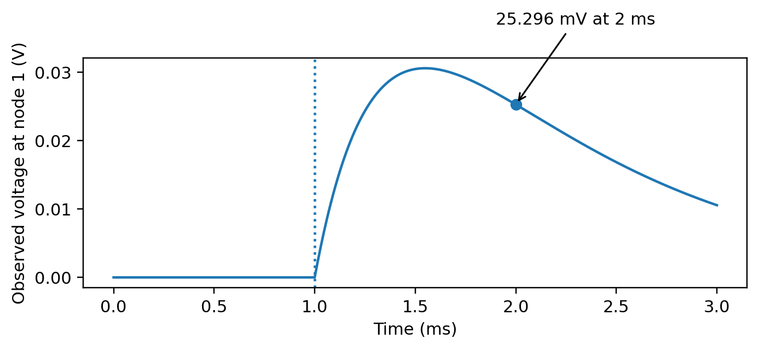
Figure 2. Observed voltage in volts. The charged hidden state becomes detectable after the allowed context switch at 1 ms.
Stored capacitor energy decreases throughout the trajectory. A present-output description nevertheless loses a future-detectable distinction. The example demonstrates why a reusable state must be closed under composed contexts, including their physical order. It is an ideal-model result, not a hardware measurement.

10. Electronic circuits: kinetics and stable records
The echo formula was checked against matrix exponentials, 500 random pairs of switching durations and an independent ODE solver at three tolerances. The finest ODE discrepancy was below 4.30 × 10⁻¹⁵ V. The observation span, closed under both transposed generators, grows through dimensions 1, 2 and 3. The hidden state becomes visible under the full protocol family. [13]
Eliminating an internal state can also produce a memory kernel. For the two-node matrix [[2, −1], [−1, 2]], the observed response is ½(e⁻ᵗ + e⁻³ᵗ), with integrated response 2/3. A memoryless one-mode approximation gives 1/2. The exact reduced equation retains both the hidden initial condition and a convolution of the observed history. [13]
Static response and timing remain distinct. A 1 kΩ resistor charging 1 µF or 4 µF reaches the same final 1 V, but its 50% times are 0.693147 and 2.772589 ms. A detection threshold defines an additional event on that continuous trajectory. [13]
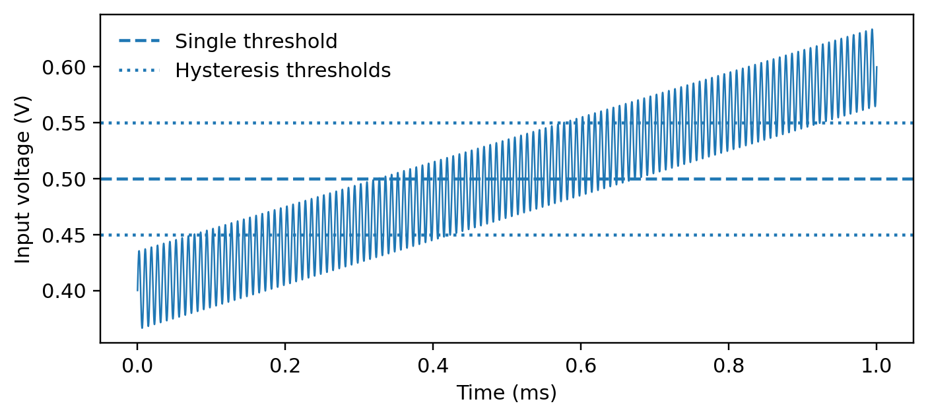
Figure 3. The declared synthetic ramp and ripple, with a single threshold and a hysteresis band. Device bandwidth and propagation delay are excluded.
For v(s) = 0.4 + 0.2s + 0.035 sin(2π·120s) V on 0 ≤ s ≤ 1, the ideal 0.5 V comparator switches 85 times. A 0.55/0.45 V hysteretic comparator, initially low, switches once. Grid refinement and independent root finding verify the counts. Hysteresis is established engineering; these numerical counts belong to this ideal fixture. [11,13]
Completion, record stability and clearance are therefore different circuit questions. A high-gain threshold does not remove settling time, and a quiet record does not certify that all hidden charge has become irrelevant.

11. Electronic circuits: persistent law and operational margin
Resetting voltage and changing a component law leave different futures. A divider with equal 1 mS input and ground conductances produces 0.5 V under a 1 V drive. A persistent input-conductance change to 1.2 mS produces 6/11 V on the next drive, even after capacitor voltage has been cleared. This supplies a concrete distinction between live state and retained constitution. [13]
A useful operational contract can specify a voltage margin, settling deadline, tolerated observation error and reset residual. For a charging RC stage with a 0.5 V threshold and adverse error bounded by 20 mV, reaching 0.52 V requires 0.733969 time constants. Discharge from 1 V to 0.01 V requires 4.605170 time constants. [13]
The capacity to perform the next operation depends on satisfying the whole contract. A single margin can be defined only after the perturbation coordinates and their metric are declared. Summing volts, seconds and watts without normalization gives a convention, not a physical invariant.

11.1 A bounded identifiability result
The supplement uses six model parameters: conductance, capacitance, measurement-noise standard deviation, hysteresis half-width, reset conductance and retained conductance rewrite. Six observables are steady output, settling time, Gaussian discrimination error, hysteresis width, reset fraction and post-rewrite output. Their formulas and operating point are included in the companion reference and executable script. [13]
$$J_{ij}=\frac{θ_{j}}{y_{i}}\frac{∂y_{i}}{∂θ_{j}}.$$
This dimensionless sensitivity matrix has rank six and condition number 85.04. The singular values range from 4.74643 to 0.05582. The model is locally structurally identifiable at the stated operating point, with an appreciably weaker practical direction. Finite-difference refinement was checked. This is not identification of a universal elemental carrier. [13]
The engineering realization makes the proposed distinctions concrete: network support, transport, global compatibility, observation, state memory, retained rewrite and reset can be changed separately. Cross-carrier transfer would require similarly explicit maps and measurements in language, script or music. Their names alone supply no such evidence.

12. Verification and the scope of the result
The supplied analysis executes 64 named checks and records all residuals and acceptance limits. All checks pass with seed 20260910 in the stated software environment. Assertions, random model trials and empirical replications are different units of evidence. [13]
An exhaustive binary triangle supplies a global-compatibility witness: three pairwise parity restrictions are individually feasible and have consistent uniform one-variable marginals. Even parity gives two global completions; odd parity gives none and requires at least one violated constraint. Local compatibility is consequently insufficient for a global object in this finite model. [13]
A weighted graph-cochain fixture checks the exact, coexact and harmonic decomposition on a square with a diagonal and one filled triangle. The harmonic space is one-dimensional. This calculation does not derive five unique functional modes: boundary ports, scales and constitutive laws add structure beyond the three-part Hodge decomposition. [12,13]
Evidence class | What is available
Ideal physical models | DC completion, hidden-state echo, clock/reset laws, comparator and sensitivity checks
Encoding operations | Nine literal-string fixtures and normalization-aware joining
Synthetic music | Phase-sensitive counterexample, tempo and transposition controls
Source-table audits | Inherited linguistic coordinates and official Groove aggregate totals
Not performed | Raw-corpus model replication, raw-MIDI analysis, hardware and human experiments

The contribution is an operational criterion for sufficient state and several exact realizations and failure witnesses. Standard Schur reduction, observability, Unicode normalization and Fourier phase are used as established instruments. Their appearance here is not claimed as a new discovery of those mathematical results.
The broader research claim remains conditional: media can be compared by whether their carrier-specific maps preserve completion, record formation and admissible reuse. The present evidence establishes coherent examples and testable separations. It does not establish a universal law of natural media or an independently measured common physiological mechanism.

References and source status
[1] The Relational Cell. Working paper v0.16. Supplied internal manuscript. Internal programme source; consulted for complete compositional autonomy, effective-state reduction and the separation of stiffness from kinetics.
[2] A Generalised Theory of a Medium. Working reference note v0.4. August 2026. Supplied internal source. Language tables: pp. 37–39 and 63–64. Earlier v0.2, v0.3 and Core Mathematical Kernel v0.1 provide the revision history.
[3] de Marneffe, M.-C., Manning, C. D., Nivre, J., and Zeman, D. (2021). “Universal Dependencies.” Computational Linguistics 47(2), 255–308. DOI: 10.1162/coli_a_00402. Primary text: aclanthology.org/2021.cl-2.11/.
[4] Universal Dependencies. “CoNLL-U Format.” Official format documentation. universaldependencies.org/format.html. Consulted 10 September 2026.
[5] Whistler, K., ed. Unicode Standard Annex #15, “Unicode Normalization Forms.” Revision 57, Unicode 17.0.0, 30 July 2025. unicode.org/reports/tr15/.
[6] Hadley, J., ed. Unicode Standard Annex #29, “Unicode Text Segmentation.” Revision 47, Unicode 17.0.0, 17 August 2025. unicode.org/reports/tr29/.
[7] Magenta. “Groove MIDI Dataset.” Official dataset description and overview table. magenta.tensorflow.org/datasets/groove. Published aggregate table consulted 10 September 2026; raw MIDI was not analysed in this revision.
[8] Jacoby, N., et al. (2024). “Commonality and variation in mental representations of music revealed by a cross-cultural comparison of rhythm priors in 15 countries.” Nature Human Behaviour 8, 846–877. DOI: 10.1038/s41562-023-01800-9.
[9] Witek, M. A. G., Clarke, E. F., Wallentin, M., Kringelbach, M. L., and Vuust, P. (2014). “Syncopation, Body-Movement and Pleasure in Groove Music.” PLOS ONE 9, e94446. DOI: 10.1371/journal.pone.0094446. Correction (2015): DOI 10.1371/journal.pone.0139409.
[10] Dörfler, F., and Bullo, F. (2011). “Kron Reduction of Graphs with Applications to Electrical Networks.” arXiv:1102.2950. Primary preprint; Schur-complement reduction of electrical networks.
[11] Kay, A., and Claycomb, T. “Comparator with Hysteresis Reference Design.” Texas Instruments, TIDU020A, 2013; revised June 2014. ti.com/lit/ug/tidu020a/tidu020a.pdf. Used for the engineering principle, not as a source of the synthetic threshold counts.
[12] Lim, L.-H. (2015). “Hodge Laplacians on Graphs.” arXiv:1507.05379. Published in SIAM Review 62 (2020), 685–715. DOI: 10.1137/18M1223101.
[13] Medium v0.5 verification supplement. analyse.py, supplied input tables, results/checks.json, results/summary.json and source_provenance.json. Run 10 September 2026 with seed 20260910. Distributed with these papers as Medium_v05_Reproducibility.zip.

Limitations and continuing questions
This paper is self-contained at the level of the state criterion and worked examples. The fivefold medium object and its elemental coordinates remain a proposed architecture. Their uniqueness, necessity and universal physical realization have not been established.
The linguistic analysis is incomplete at raw-data level. The supplied rounded tables were checked for transcription and arithmetic. Original corpus files, features, grouping and fitted estimators were not reproduced. Their values consequently support no new confidence interval, significance test or causal language comparison.
The musical corpus contribution is restricted to published aggregate totals. Raw MIDI performance statistics and measured listener responses were not analysed. The phase example proves a failure of one coarse representation, while its perceptual and physiological consequences remain empirical questions.
The script example concerns canonical normalization and a small set of executed strings. Its success does not identify visual units, verify every Unicode rule, model all shaping systems or establish a neurological mechanism of reading.
The circuit examples assume ideal components and switching. Real hardware adds bandwidth, noise, tolerance, temperature, parasitics and charge injection. The model echo and threshold counts are reproducible calculations; hardware confirmation remains absent.
Sufficient boundary state is task-dependent. Changing the future protocol family can make previously discarded memory relevant. Approximate reductions additionally require explicit bounds on accumulated error, and a distance threshold by itself need not define a lawful quotient.
The next theoretical burden is also specific: retain kinetics separately from static cost; handle metastable branches without erasing their history; specify the measure in kernel gluing; and distinguish a functionally useful mode decomposition from a unique physical derivation. These gaps are visible in the current formulation rather than hidden inside a common vocabulary.
The present result is a workable language for comparing constituted processes, supported by exact model instances and bounded empirical audits. Its larger scientific value will depend on whether independently measured carrier maps yield additional predictive discrimination beyond established domain-specific models.

